RECENT TRENDS IN PASSIVE COOLING & HVAC SYSTEMS FOR BUILDINGS – A LITERATURE REVIEW
Shivam Hemant Dandgavhal*,

*Department of Mechanical Engineering, K.K.Wagh Institute of Engineering Education & Research, Savitribai Phule Pune University, Nashik, 422003, India.

Presenting author: shivamdgavhal@gmail.com

ABSTRACT
An in-depth review of current & upcoming technologies for achieving “Passive Cooling & HVAC systems” has been presented in this paper. As per the “Energy Performance of Building Directive” framed by European commission, nearly zero energy building (nyZEB) condition will be compulsory for all buildings erected/constructed by end of the year 2020 for all European member states. As the massive amount of total annual energy consumption in a country is spent on residential complexes & buildings, a huge potential is available to optimize the power consumption & improve the energy efficiency. This paper particularly focuses on recent trends in passive cooling & HVAC system for the sake of achieving energy efficient air conditioning & ventilations in buildings.
Keywords: - Free Cooling, Passive Cooling, Heating ventilation & air conditioning (HVAC) systems, Zero Energy Buildings (ZEB), Phase Change Material (PCM), Low Energy Building (LEB).

1. INTRODUCTION
Passive energy efficient Cooling and Heating implies utilization of organic building design doctrines with natural climate resources to foster greener & sustainable growth of the human living environment and obtain excellent building energy efficiency. Approx. 40% of total primary energy consumption is utilized by building energy consumption in United States and E.U [1]. As per the Energy Performance of Building Directive for European member states, Nearly Zero Energy Building will be compulsory condition for all new buildings constructed by ending of the year 2020 [2]. These conditions targets buildings, which are the main concern for research to optimize the power consumption & energy efficiency.
Because of global concern on substantial energy consumption in building sector, Low Energy Building Concept (LEB) was formulated. Appropriate selection of glazing for windows & sky lights, Proper window positioning & day light design, usage of light/reflective colored material for making roof and envelope, accurate sized glass shading, correct siting & orientation verdicts, effective landscaping design are some of the design tactics to optimize the necessity of mechanical cooling & HVAC (Heating, ventilation & air conditioning) systems.
Shading structures which intensely diminish solar gain, usage of insulation materials possessing controlled thermal inertia, air tightness & reflective properties both for transparent as well as opaque elements, usage of energy efficient lighting, heating, cooling & air conditioning equipment’s, employment of natural & recovery ventilation system at maximum possible level, compulsory use of night ventilation are the design aspects to be considered while designing LEB.
Passive cooling & HVAC energy saving systems is superfluous to get zero energy consumption by implementing applications like trombe wall, natural ventilation, lightweight concrete wall, energy efficient architectural design and roof greening. By controlling the way of ventilation & sensible use of natural wind, significant reduction in refrigeration & ventilation energy consumption can be achieved.
This Literature Review is focused on the major applications & techniques to achieve LEB, zero energy conditions as well as achieving passive cooling and HVACs.
Figure 1. Representation of Passive Design Schemes for cooling. [3]
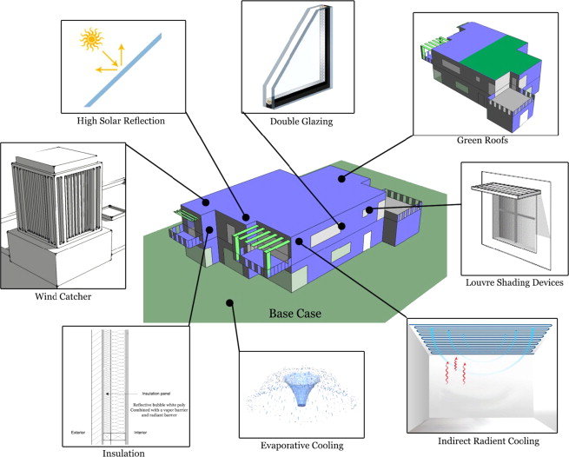
Figure 2. Flowchart of Classification of Passive Cooling Techniques.

2. LITERATURE REVIEW
This chapter is an assessment of the present state of art of the wide and complex field of Passive Cooling and Heating Techniques in Buildings and its application. In addition, this chapter separately reviews what done in the past in the area of application.
E. Bayir et al [4] conducted a case study of interior thermal comfort in passive houses, which are actually buildings, in which thermal comfort is attained by post heating or post cooling of fresh air, v.i.z required to attain appropriate indoor air conditioning without the necessity of added recirculation of air. Use of thick & high Quality Insulation Material, cold & hot water circulating through underground pipes, roof mounted photovoltaic panels for heating water & passive house certified three-storey glass window panes enables wider heat dissipation & energy efficiency.
Alam et al [5] studied the Phase Change Material (PCM) as an energy efficient means of passive cooling applications in buildings. Experimental project consisted of installing 220 kilo-grams PCM in Bed2Zone of a Duplex home. PCM Mats were installed in Ceiling for passive application, whereas as a distinct PCM storage cell was implemented for free cooling application.
Figure 3. Prototype house for passive cooling research & Diagram of Experimental setup [5].
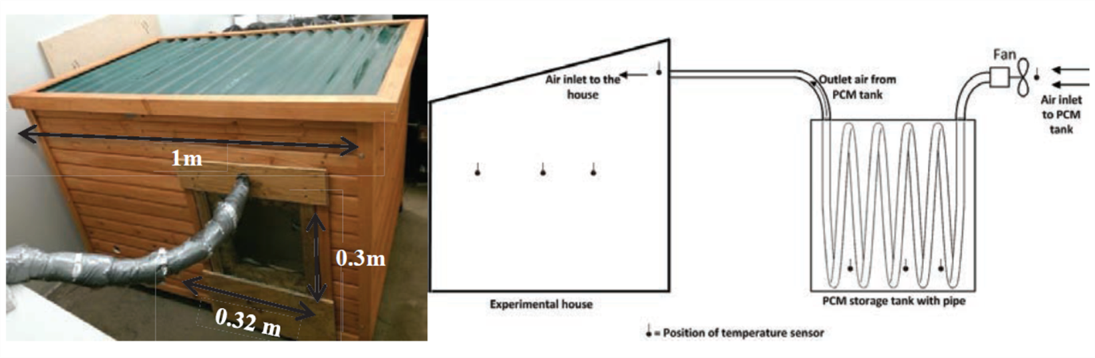
EnergyPlus V8.4 & computational fluid dynamics (CFD) software ANSYS V15.1 were used for the validation of developed simulation models with experimental data of PCM application methods. Results revealed that the novel free cooling method proved to be more effective than passive method in decreasing the internal room temperature.
M. Grosso et al [6] have researched on development of new modular wall system for sake of natural/hybrid passive cooling. The Laboratory experiments consisted of investigation of specific air humidity control via latent-heat adsorption units inclusive of zeolites & silica gel in conjunction with vacuum water solar collectors system for heat regeneration, Recovery of Sensible heat from returning air with aid of low pressure cross flow heat exchanger & investigation of a passive/free evaporative cooling system. Although the laboratory results shows a great potential, Actual implementation & case study of real application needs to evaluated, which gives the scope for future research.
W. Rashdi and M. Embi [7] utilized the Auto Desk Ecotect software for simulational analysis of effect of optimal building form on cooling load. It was found that the lower surface to volume ratio & Compact form results in low cooling load, whereas the surfaces with high surface to volume ratio & exposure to sun radiations results in higher cooling requirement. Also inclining the long axis an architecture looking in the north direction is the best option for achieving passive cooling in buildings.
T. Santos et al [8] conducted a case study & analyzed the performance of LTES – Latent Thermal Energy Storage as a solution in achieving optimal cooling energy consumption in buildings. The system comprises of a Mechanical Ventilation unit which employs phase change material (PCM) thermal storage across ventilation route. PCM is solidified by the night cooled air and during the melting state of the PCM, air is cooled & circulated. Results depict that indoor Air Quality and internal room temperature is maintained between thermal comfort perimeters at a low energy cost in comparison with AC equipped buildings.
H. Ma et al [9] conducted a case study and analyzed the reports of energy consumption & operating cost before & after the implementation of practical passive & active energy saving technologies in a ultra-low energy consumption building having energy consumption in the range approx. 36kWh/m².a. Results depicted a great deal of decrease in the operating cost over 50 % & energy consumption of the building by over 15% making it an ultra-low energy consumption building.
Venkiteswaran et al [10] compared & analyzed the passive cooling methods inclusive of single low-emissivity window glazing, wall insulation by polystyrene & white painted roof with aid of CFD analysis utilizing ANSYS© Fluent software.
Figure 4. Temperature profile results of analysis using ANSYS software when all methods applied, with view from three altered orientations. [10]
Results portrayed that use of these methods combined helped in decreasing the temperature by 0.98 degree Celsius & monthly energy consumption by 9.5%. However, wall insulation by 50 mm thick polystyrene proved to be the most efficient method in all aspects.
Liang et al [11] monitored & evaluated the performance of passive & conventional house in North East England for time period over a year. Design builder software was utilized to develop simulation models validated with monitored data to forecast the functioning of conventional house retro fitted with passive cooling techniques & later comparison with passive house.
Figure 5. Exterior wall of Conventional House before & after Retrofitting in figure a & b respectively. [11]
For the simulation studies, outward surface of exterior wall, roof level & interior surface of floor slab were equipped with 15 cm thick polyurethane board; whereas the doors & windows were improved with triple glazing of good quality. Concluding the brief study, Retro-fitting of passive cooling techniques in the conventional house shows promising results in optimizing the energy consumption & improving indoor thermal comfort.
Z. Emdadi et al [12] investigated the development of porous geo polymer, which are prepared primarily from the byproducts, agricultural waste & industrial residues by implementing an ecofriendly procedure at low temperature firing ranges. Geo-polymer as a means of passive evaporative cooling application has been illustrated. Surface of PECW is designed to be cooled due to evaporation, whereas the solar shading helps in protection from reflected & direct solar radiations.
Figure 6. Detailed Illustration of a passive evaporative cooling wall fabricated from porous raw material with water retaining capability. [12]
T. Kisilewicz [13] analyzed the factors affecting internal climate in Low Energy Buildings (LEB). EnergyPlus software was utilized to develop a dynamic thermal simulation model. Design of windows/glazed openings influences the thermal climate in architecture’s & buildings. Shading structures & mechanisms like shutters, glazing with variable properties, overhangs and movable or fixed shading elements, etc. should be employed for glazed opening systems. Night cooling was found to be feasible & effective in most cases. Thermal Insulation of building didn’t result in leaving a negative impact on indoor micro-climate.
Bragança et al [14] investigated the performance comparison of lobe - inserted diffuser with the conventional multi cone ceiling diffuser in HVAC systems for the sake of better mixing of air jet with ambient air for better ventilation & comfort indoors. Analytical Results centered on ISO 7730 & ASHRAE 55 standards indicated that lobed diffuser proved to be a promising solution in improving the thermal comfort for both heating & cooling modes without rise in sound pressure levels & pressure drops.
Giacomo Chiesa et al [15] conducted a case study & evaluated the incorporation of (PDEC) passive downdraught evaporative cooling system in buildings. PDEC system works on the principle of downdraught air movement caused by buoyancy because of fall in air temperature by water evaporation.
Figure 7. Proposed Passive Down Draught Evaporative System.[15]
Findings of the analysis stated that the buildings can be easily equipped with PDEC systems without bargaining sensitive & aesthetic characteristics of the architecture, Also the PDEC systems must consider site dependent & indoor thermal comfort requirements & characteristics from the pre design stage itself for accurate dimensioning & positioning of the system.
Z. Qingyuan and L. Yu [16] investigated the potential of radiative & evaporative cooling by simplifying the calculations with reference from data of 360 locations of a meteorological year. The research concluded that, with rise in latitude & elevation of location, rise in effective radiation cooling potential was observed. Variance amongst the humidity ratio of evaporating surface & outdoor widely affects the evaporative cooling potential. Also the Formulation of equations to predict the evaporative & radiative cooling potential of any location in China was done.
H. Mastouri et al [17] thrived to accomplish energy savings & thermal comfort in interiors of buildings by combining passive methods & employing the use of pebbles bed, which played the role of a thermal storage system. The Actual Practical activity consisted of laying out the pebbles bed in excavated earth & making a connection with the air tower for purpose of thermal charge/discharges & air circulation to/from the pebbles bed.
Figure 8. Plan of Pebbles bed & Layers of Pebbles Bed wrapped with Polyane Film [17].
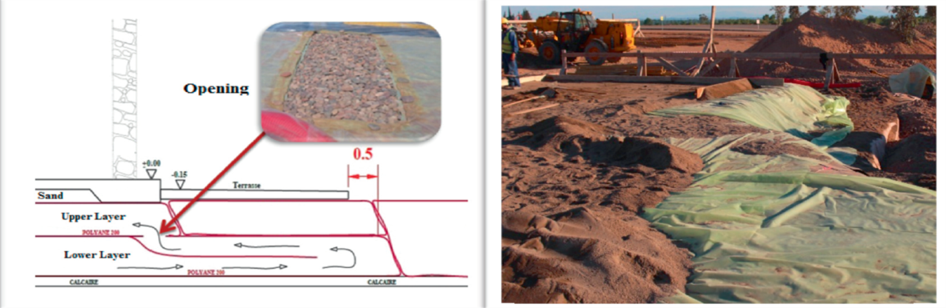
Analysis concluded that the electric power consumption for air conditioning requirements can be optimized to a good potential by employing the installation of pebbles bed.
Xiong et al [18] put forth the analysis & feasibility reports of using controllable ceiling/roof in traditional residences after renovation. Night Ventilation with proper insulated controllable ceiling was strongly advised as passive cooling measure & means of energy conservation. The Change in Energy consumption & indoor temperature before & after the renovation was evaluated with use of Design Builder software, which depicted promising 54.35 % as energy efficiency. The indoor temperature was able to be reduced by 1.9 degree Celsius after the transformation from uncontrollable to controllable ceiling.
Huixing Li et al [19] designed a novel physical model on simulation basis of cooling & heating requirements of AC system for a zero energy consumption building from a cold region with help of DeST software. Use of passive applications inclusive of Wind Tunnel, outside insulated wall, Heat recovery from exhaust air, Low-e glass & phase change energy storage were utilized in this process for research considerations & for sake of comparison between AC load variation influencing factors of Low energy building with that of a conventional building. The Combined effect of employing all these passive applications resulted in decrease in 73.72% of heating load in winters & an impressive savings of 55.22% can be done in annual energy consumptions.
A. Prieto et al [20] formulated a framework presenting the modern potentials of facade solar cooling integration with help of solar cooling façade concepts & technologies put forth previously in literature. Research concluded in presentation of a matrix assessing the examples & case studies from modern research work & field projects for R&D in façade solar cooling integration & lastly summarizing the potentials for combination of numerous elements & subsystems in whole cooling process.
B. Sun et al [21] focused on optimizing the energy consumption capital by establishing methodology considering main interactions of building functions & applications. Combination of Lagrangian relaxation, rollout technique & stochastic dynamic programming (DP) was developed to achieve proficient integration plans in systematic manner. Development of optimization plans for luminance/HVAC system & experimental rules to harmonize with natural ventilation & shading blinds was done. The above equipped method proved to be scalable & offers a promising savings in energy consumption & bills.
R. Han et al [22] worked to minimize the cooling load for AC systems without compromising peoples comfort requirements by proposing a novel creation of water holding roof bricks. To discover the extents of heat transfer in summer & winter seasons, designing of investigational model for passive evaporation was done, which resulted in fall of indoor temperature by 1.9 degree Celsius for flat roof built with water holding bricks.
Figure 9. Water Retaining Bricks Photos & Structure Diagram. [22]
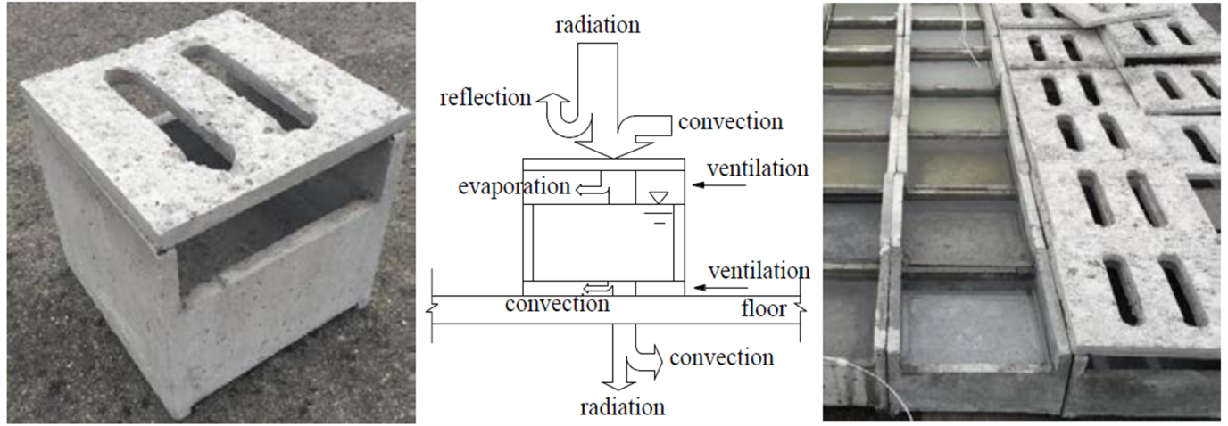
Although the water holding roof contributes more in reducing cooling load & increasing thermal indoor comfort, further reduction in cooling load can be achieved by employing the use of radiation shield on rooftop.
M. Moldovan et al [23] portrayed a research & case study based on renewable system applications of solar cooling & heating for the sake of attaining nearly zero energy building condition. Utilization of passive design system along with renewable energy (solar thermal) systems was advocated in the developed incorporated design methodology by understanding the climatic profile of unbalanced cooling & heating requirements for better economic gains.
3. CONCLUSION & FUTURE SCOPE
State of the art literature & research work done by various research scholars from the year 2013 to the current year 2018 has been reviewed & summarized in this paper. Various inputs given by the researchers in their work along with results of experiments has been featured in this paper. Scope for further research in the area of “Passive Cooling, Heating, Ventilation and Air Condition of the Building” is investigated & proposed in this paper. Following are the identified research areas & observations, based on this state of the art literature review.
- Amplifying the solidification rate of Phase Change Material.
- Numerical Modeling & Experimental Investigation of Phase Change Material to boost the heat transfer rate of PCM.
- Development of Economic production methodology for manufacturing Phase Change Material in Cost, Quality & Volume aspects.
- Developing transient analytical model to evaluate & analyze the efficiency of polystyrene wall insulation by also considering the direction of solar radiation.
- Checking the compatibility of Passive Down – Draught Evaporative cooling System in diverse climatic conditions, seasons & locations. Tabulating a database for the same.
- Cost Optimization of retrofitting a controllable insulated ceiling in a traditional residence.
- Developing a energy monitoring system for a zero energy, low energy and nearly zero energy buildings for accurate analysis of energy consumption & potential savings.
- Study of Effect of Terminal devices like VAV boxes & humidifiers in HVAC systems on Energy Consumption & Indoor Thermal comfort. And devising the methodology & potentials of Passive means of reducing energy consumption for the same.
- Developing an Aesthetic approach towards the integration & retro fitting of passive energy saving technologies in the buildings.
- Implementing the use of compact space oriented gardening & landscaping in buildings as a means of passive decrease in energy consumption & increasing the indoor comfort conditions.
- Suggesting design strategies for bringing co-ordination between mostly used active & passive sources of cooling & HVACs.
- Developing and feasible aesthetic modular approach towards the integration of passive cooling & HVAC systems.

REFERENCES
[1] Xiaodong Cao, Xilei Dai and Junjie Liu (2016), “Building energy-consumption status worldwide and the state of the art technologies for zero energy buildings during the past decade”, Elsevier, Energy and Buildings, Volume 128, pp. 198-213.
[2] European Commission. Nearly zero-energy buildings. [online] Available at: https://ec.europa.eu/energy/en/topics/energy-efficiency/buildings/nearly-zero-energy-buildings . [Accessed 19 Feb. 2018].
[3] Hanan M. Taleb (2014), “Using passive cooling strategies to improve thermal performance and reduce energy consumption of residential buildings in U.A.E. buildings”, Elsevier, Frontiers of Architectural Research, Volume 3, Issue 2, pp. 154 – 165.
[4] Esra Bayır, Merve Karaoğlu and Nuriye Nida Çelebi Şeker (2013), “The Analysis on Examples of Energy Efficiency in Passive Houses in Terms of Interior Comfort”, International Conference on Renewable Energy Research and Applications, Madrid, 20-23 October 2013, IEEE.
[5] Morshed Alam, Jay Sanjayan, Patrick X.W. Zou, Sayanthan Ramakrishnan and John Wilson (2017), “A comparative study on the effectiveness of passive and free cooling application methods of phase change materials for energy efficient retrofitting in residential buildings”, Elsevier, Procedia Engineering, Volume 180, pp. 993 – 1002.
[6] Mario Grosso, Gianvincenzo Fracastoro, Marco Simonetti and Giacomo Chiesa (2015), “A hybrid passive cooling wall system: concept and laboratory testing results”, 6th International Building Physics Conference, Elsevier, Energy Procedia, Volume 78, pp. 79 – 84.
[7] Wan Sharizatul Suraya W.M. Rashdi and Mohamed Rashid Embi (2016), “Analysing Optimum Building Form in Relation to Lower Cooling Load”, Annual Serial Landmark International Conferences on Quality of Life, Elsevier, Social and Behavioral Sciences, Volume 222, pp. 782 – 790.
[8] Thiago Santos, Chris Wines, Nick Hopper and Maria Kolokotroni (2018), “Analysis of operational performance of a mechanical ventilation cooling system with latent thermal energy storage”, Elsevier, Energy & Buildings, Volume 159, pp. 529 – 541.
[9] Hongting Ma, Weiye Zhou, Xinyu Lu, Zequn Ding and Yang Cao (2016), “Application of Low Cost Active and Passive Energy Saving Technologies in an Ultra-low Energy Consumption Building”, Elsevier, Energy Procedia, Volume 88, pp. 807 – 813.
[10] Vinod Kumar Venkiteswaran, Jason Liman and Saqaff A. Alkaff (2017), “Comparative Study of Passive Methods for Reducing Cooling Load”, Elsevier, Energy Procedia, Volume 142, pp. 2689 – 2697.
[11] Xinxin Liang, Yaodong Wang, Mohammad Royapoor, Qibai Wu and Tony Roskilly (2017), “Comparison of building performance between Conventional House and Passive House in the UK”, Elsevier, Energy Procedia, Volume 142, pp. 1823 – 1828.
[12] Zeynab Emdadi, Nilofar Asim, M. A. Yarmo and Roslinda Shamsudin (2014), “Investigation of More Environmental Friendly Materials for Passive Cooling Application Based on Geopolymer”, Elsevier, APCBEE Procedia, Volume 10, pp. 69 – 73.
[13] Tomasz Kisilewicz (2015), “Passive control of indoor climate conditions in low energy buildings”,Elsevier, Energy Procedia, Volume 78, pp. 49 – 54.
[14] Pierre Bragança, Kodjovi Sodjavi and Amina Meslem (2017), “Passive Control Strategy For Mixing Ventilation In Heating And Cooling Modes Using Lobed Inserts”, Elsevier, Energy Procedia, Volume 112, pp. 232 – 239.
[15] Giacomo Chiesa, Mario Grosso, Alessio Bogni and Giacomo Garavaglia (2017), “Passive downdraught evaporative cooling system integration in existing residential building typologies: a case study”, Elsevier, Energy Procedia, Volume 111, pp. 599 – 608.
[16] Zhang Qingyuan and Liu Yu (2014), “Potentials of Passive Cooling for Passive Design of Residential Buildings in China”, Elsevier, Energy Procedia, Volume 57, pp. 1726 – 1732.
[17] Hicham Mastouri, B. Benhamou and H.Hamdi (2013), “Pebbles Bed Thermal Storage for Heating and Cooling of Buildings”, Elsevier, Energy Procedia, Volume 42, pp. 761 – 764.
[18] Ke Xiong, Zhenjing Yang and Jiandong Ran (2017), “Research on Passive Energy – saving Renovation of the Roof of Traditional Residences”, Elsevier, Energy Procedia, Volume 141, pp. 240 – 244.
[19] Huixing Li, Ran Zhang, Guohui Feng, Kailiang Huang and Chihong Cao (2015), “Simulation and Comparison of Heating and Cooling Load between a Zero-Energy Building and a Common Building in Severe Cold Region”, Elsevier, Procedia Engineering, Volume 121, pp. 1505 – 1509.
[20] Alejandro Prieto, Ulrich Knaack, Thomas Auer and Tillmann Klein (2017), “Solar coolfacades: Framework for the integration of solar cooling technologies in the building envelope”, Elsevier, Energy, Volume 137, pp. 353 – 368.
[21] B. Sun, P. B. Luh, Q. S. Jia, Z. Jiang, F. Wang and C. Song (2013), "Building Energy Management: Integrated Control of Active and Passive Heating, Cooling, Lighting, Shading, and Ventilation Systems," in IEEE Transactions on Automation Science and Engineering, vol. 10, no. 3, pp. 588-602.
[22] Rubing Han, Zhimao Xu and Yutao Qing (2017), “Study of passive evaporative cooling technique on water-retaining roof brick”, Elsevier, Procedia Engineering, Volume 180, pp. 986 – 992.
[23] Macedon D. Moldovan, Ion Visa, Mircea Neagoe and Bogdan G. Burduhos (2014), “Solar heating & cooling energy mixes to transform low energy buildings in nearly zero energy buildings”, Elsevier, Energy Procedia, Volume 48, pp. 924 – 937.

