IndiaTrib – 2019
Research Article

Thermal Analysis OF TWO LOBE NON-Recessed Hybrid Journal Bearings

Dr.P.B.Kushare^{1*} and Prof. Satish C.Sharma²
¹ K.K.Wagh Institute of Engineering Education and Research, Amrutdham, Nashik-422003, India
² Indian Institute of Technology, Roorkee. 247667, India
*Corresponding author (E-mail: pbkushare@gmail.com)

KEY WORDS: Thermal; Two Lobe; Hybrid; Journal Bearing.

Abstract
In this paper, an influence of thermal effect on the static and dynamic performance characteristics of capillary compensated two lobe non-recessed hybrid journal bearing systems is presented. The Reynolds equation, energy and conduction equations have been solved simultaneously to get its solution using finite element method and a suitable iterative scheme. The numerically simulated results for the symmetric bearing configuration have been presented for different values of offset factors. The numerically simulated results of the study indicate that the temperature rise considerably changes the performance of two lobe non-recessed journal bearing systems. A proper selection of bearing geometry may compensate the loss occurred due to temperature rise partially.

introduction
In the twenty first century fast pace of life led to the development of modern machinery to cope with the rigorous constrains and operating conditions. Thus, the bearing designers are faced with onerous task of designing the machine with better efficiency, accuracy and more run time to failure. Such limits might be the peak temperature of the lubricant and bearing materials. At high speed, heat is generated in fluid film of the bearing system due to friction. As a consequence of this, viscosity variation causes substantial reduction in the value of minimum fluid film thickness and it alters the bearing performance. Thus, the prediction of temperature distribution in journal bearings for realistic bearing performance data generation has been the goal of many researchers in the last four decades
The theoretical study of the temperature distribution in the clearance space of the bearing has begun in the early 60’s with the work of Hunter and Zienkiewicz [1]. Later on, Dowson [2] presented the generalized Reynold’s equation which includes the variation of the lubricant viscosity both along and across the fluid-film. This approach was later found to be quite popular and was adopted by several investigators. Har Prashad [3] developed a technique for performance evaluation of a bearing based on the maximum oil temperature in the region of load carrying fluid-film and variation of oil viscosity with temperature. Using finite difference method, Boncompain and Frene [4] solved the 3D energy equation in the fluid domain and the 2D heat conduction equation for the bearing. They investigated the static and dynamic characteristics of a finite bearing operating under laminar conditions. They observed a significant change in the value of fluid film stiffness and damping coefficients due to thermal effect. Later on, Ferron et al [5] followed a similar method by incorporating 3D heat conduction equation for the bearing. They investigated theoretically the influence of thermal effect as well as the experimentally in finite length journal bearing. They found a good conformity with calculated results for pressure and temperature but observed deviation in eccentricity ratio because of thermal deformation along with differential thermal dilatation between journal and bearing in both theoretical and experimental studies. In recent years, many studies, which dealt with the thermoelastohydrodynamic (TEHD) analysis of hydrodynamic journal bearings, have reported in the literature [6,7]. Sinhasan and Chadrawat [6] analyzed a two axial groove journal bearing including thermoelastohydrodynamic effects. They used the finite element method to solve the governing equations and the conventional 3D energy equation.Khonsari and Wang [7] extended the THD analysis of journal bearing to include provisions for the shaft thermal dilation as well as the bush thermoelastic deformation.
Sheeja and Prabhu [8,9] investigated the combined influence of thermal and non-Newtonian effects on the performance of hydrodynamic journal bearing both theoretically and experimentally.
It is amply clear from the review presented in this sub-section that quite an exhaustive literature dealing with the influence of thermal effect on plain hydrodynamic journal bearings is available and extensively studied by many investigators. Very few number of studies have been carried out for hydrostatic/hybrid journal bearings. So and Chang [10] carried a theoretical investigation of thermal effect on the performance characteristics of single recessed hybrid journal bearing. They assumed that the heat generated by shearing is carried away only by the fluid flow and there is no heat transfer to or from the solid surfaces (adiabatic conditions). Braun et al. [11] proposed a thermohydraulic model to study the performance of a hydrostatic journal bearings used in the turbo pumps of the space shuttle main engine. The Reynold’s equation was coupled with 2D energy and 3D conduction equations to obtain the coupled solution. TEHD studies have had the attention of many researchers in recent times. Sharma et al. [12] and Vijay Kumar et al. [15] carried out a theoretical investigation of influence of thermal effect on the performance of circular hole entry and slot entry hybrid journal bearing. They reported that the temperature-viscosity dependence of the lubricant reduces the bearing stability. They [12,13] extended their thermohydrostaic study along with the bush deformation in the analysis. They solved 3-D energy equation together with 3-D conduction equation simultaneously to establish the equilibrium of heat flow from lubricant to surrounding through the bearing bush. Nagaraju et al.[13,14] carried out thermo-hydrostatic analytical study of the combined influence of surface roughness[13] effect and non-Newtonian lubricant [14] .They reported that the rise in fluid film temperature have a significant effect on viscosity variation, bush deformation, surface roughness parameters, which ultimately affect the bearing performance.
A recent study by Kushare and Sharma [16] reported an effect of temperature on the performance of 2-lobe symmetric hole entry hybrid journal bearing operating with non-Newtonian lubricant. The results of their studies indicated that the variation of viscosity of cubic law lubricant due to temperature rise and bearing geometry changes the bearing performance quite significantly. The scan of the literature indicates that majority of studies which have carried out and reported by considering thermal effects are for the hydrodynamic journal bearings and a very limited number of studies are available for the case of circular hydrostatic/hybrid non-recessed bearings. Till date, no study has yet been reported in literature that addresses thermal analysis of two lobe non-recessed hybrid journal bearings compensated with capillary restrictor.
Therefore, present work is aimed to bridge the gap in literature. The geometry of two lobe non-recessed hybrid journal bearing is shown in Fig.1.

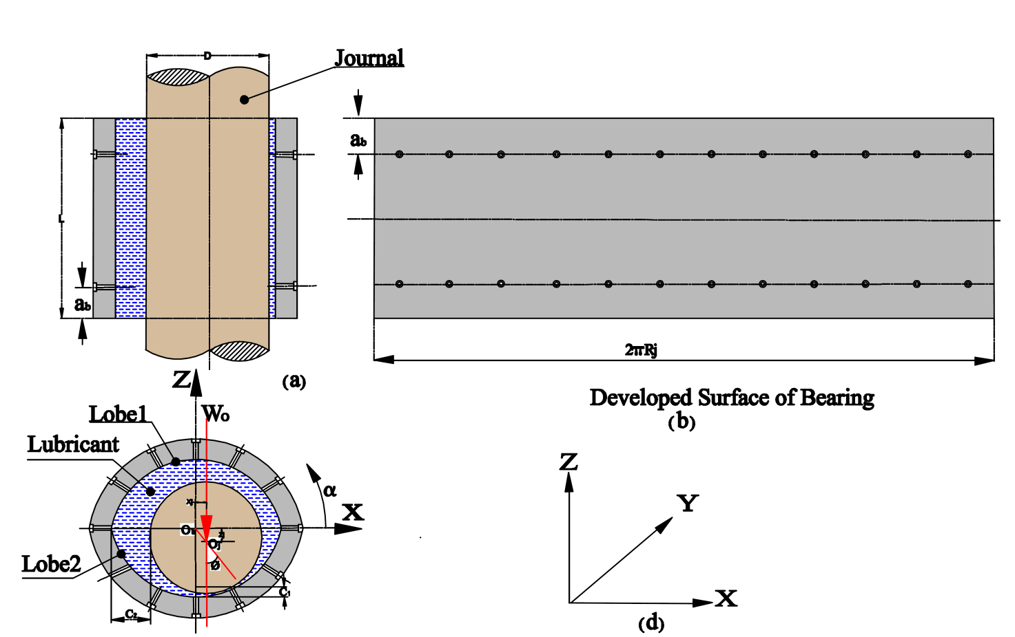
Fig. 1: Geometry of symmetric two lobe non-recessed hybrid journal bearing.
ANALYSIS:
The modified form of Reynolds equation for 2-lobe journal bearing is expressed in non-dimensional form as [16]:
$$\frac{∂}{∂α}\left({\bar{h}}^{3}{\bar{F}}_{2} \frac{∂\bar{p}}{∂α}\right)+\frac{∂}{∂β}\left({\bar{h}}^{3}{\bar{F}}_{2} \frac{∂\bar{p}}{∂β}\right)=Ω\left[\frac{∂}{∂α}\left\{\left(1−\frac{{\bar{F}}_{1}}{{\bar{F}}_{0}}\right)\bar{h}\right\}\right]+\frac{∂\bar{h}}{∂\bar{t}}$$
Modified three-dimensional energy equation is used to obtain the fluid-film temperature distribution in the fluid domain. The modification in energy equation is incorporated using thin-film approximation and changing the shape of the film into a rectangular field [2]. For the entire fluid domain, the following assumptions have been made in the analysis of the three-dimensional energy equation and can be expressed as [14, 15, 16]
${\bar{h}}^{2}\left[\bar{u}\frac{∂{\bar{T}}_{f}}{∂α^{}}+\bar{v}\frac{∂{\bar{T}}_{f}}{∂β^{}}+\frac{\bar{w}}{\bar{h}}\text{.}\frac{∂{\bar{T}}_{f}}{∂\bar{z}}\right]={\bar{P}}_{e}^{}\left(\frac{∂^{2}{\bar{T}}_{f}}{∂{\bar{z}}^{2}}\right)+{\bar{D}}_{e}\bar{μ}\left[{\left(\frac{∂\bar{u}}{∂\bar{z}}\right)}^{2}+{\left(\frac{∂\bar{v}}{∂\bar{z}}\right)}^{2}\right]$Heat Conduction Equation
The 3-dimensional Fourier heat conduction equation is applied to establish the temperature distribution in the bush. In cylindrical co-ordinate system, the heat transfer equation is written in non-dimensional form as [14, 16]:
$$\frac{∂^{2}{\bar{T}}_{b}}{∂{\bar{r}}^{2}}+\frac{1}{\bar{r}}\frac{∂{\bar{T}}_{b}}{∂r}+\frac{1}{{\bar{r}}^{2}}\frac{∂^{2}{\bar{T}}_{b}}{∂α^{2}}+\frac{∂^{2}{\bar{T}}_{b}}{∂β^{2}}=0$$
Boundary Conditions:
The boundary conditions relevant to the lubricant flow field described as [14,16]:
- At the external boundary, nodal pressures are zero.
- All Nodes situated on holes have equal pressure.
- At the trailing edge of the positive region, $\bar{p}=\frac{∂\bar{p}}{∂α}=0\text{.}0$
RESULTS and DISCUSSION:
The performance characteristics of lobed symmetric non-recessed journal bearings have been obtained for the value of bearing geometric and operating parameters [14, 16] by using the analysis and an iterative solution scheme. An increase in temperature is considered by computing the value of inverse Peclet number (${\bar{P}}_{e}^{}$) and dissipation number (${\bar{D}}_{e}$) from fluid properties. In published literature, no data is available for 2-lobe symmetric non-recessed hybrid journal bearing. Therefore, to validate the developed numeric model, the computed results for circular journal bearings are validated and compared with the earlier published results of Ferron et al. [5] as shown in Fig.2. The computed result agrees quite well. Figs.3 and 4 depicts the variation of direct fluid film stiffness coefficients (${\bar{S}}_{{}_{\text{11}}}$/${\bar{S}}_{{}_{\text{22}}}$). It indicates that the value of direct fluid film stiffness coefficient (${\bar{S}}_{{}_{\text{11}}}$/${\bar{S}}_{{}_{\text{22}}}$) gets reduced due to thermal effects (THS).The influence of temperature rise a have a noteworthy effect on the value of direct fluid film stiffness coefficients (${\bar{S}}_{{}_{\text{11}}}$/${\bar{S}}_{{}_{\text{22}}}$).as a consequence of this , a reduction in the value of ${\bar{S}}_{{}_{\text{11}}}$/${\bar{S}}_{{}_{\text{22}}}$ is observed of the order of 4% and 6% for circular journal bearing than 2- lobe bearing operating at $δ>1\text{.}0$. The bearing with offset factor greater than one provides higher value of direct fluid film stiffness coefficient (${\bar{S}}_{{}_{\text{22}}}$) than the circular bearing for the same operating condition.

Fig. 2: Variation of eccentricity ratio ($ε$) with load.
The bearing performance characteristics such as${\bar{S}}_{{}_{\text{11}}}$,${\bar{S}}_{{}_{\text{22}}}$ and ${\bar{ω}}_{{}_{\text{th}}}$ have been presented through the Figs.3- 5 for different values the offset factor ($δ$).

IHS THS

Fig.3: Variation of direct fluid film stiffness coefficients (${\bar{S}}_{{}_{\text{11}}}$)

Fig.4: Variation of direct fluid film stiffness coefficients (${\bar{S}}_{{}_{\text{22}}}$).
Fig.5: Variation of stability threshold speed margin (${\bar{ω}}_{\text{th}}$)
The variation in the value of ${\bar{ω}}_{\text{th}}$ for IHS and THS condition is presented in Fig.5 for 2-lobe symmetric non-recessed bearing configuration. The rise in temperature (THS) shows deterioration in the value of ${\bar{ω}}_{\text{th}}$ .The maximum reduction in the value of ${\bar{ω}}_{\text{th}}$ is 4-6 % in THS (thermal) than that of IHS (isothermal) condition. This trend is expected in the value of${\bar{ω}}_{\text{th}}$ because of dynamic coefficients. Further it may be revealed that a proper selection of bearing geometry is required to obtain a particular value of ${\bar{ω}}_{\text{th}}$.

CONCLUSIONS
- The influence of thermal effect is to reduce the values of rotordynamic coefficients and stability threshold speed margin of 2-lobe hybrid journal bearing system.
- The lobed non-recessed hybrid journal bearing with offset factor greater than one shows improved bearing performance.
- The loss in stability threshold speed margin can be compensated by selecting proper bearing geometry

REFERENCES
- Hunter W. and Zeinkiewicz O. Effects of Temperature Variation Across the film in the Theory of Hydrodynamic Lubrication. Jr. of Mech. Engg. Sc., 1960, Vol. 2(1), pp. 52.
- Dowson D. A Generalized Reynold’s Equation for Fluid Film Lubrication. Int. Jr.of Mech. Sci., 1962, Vol. 4, pp.159-170
- Prashad H. The Effects of Viscosity and Clearance on the Performance of Hydrodynamic Journal Bearings. STLE, Tribology Transaction, 1988, Vol.1 (2), pp.113–23.
- Boncompain R. and Frene J. Thermohydrodynamic Analysis of a Finite Journal Bearings Static and Dynamic Characteristics. Proc. 6th Leeds-Lyon Symp on Tribology, 1979, lyon, France, Paper I (iii), pp. 33.
- Ferron J., Frene J. and Boncompain R. A Study of Thermohydrodynamic Performance of a Plain Journal Bearing Comparison between Theory and Experiments. Trans. ASME, Jr. of Lub. Tech., 1983, Vol. 105, pp. 422-428.
- Sinhasan R. and Chandrawat H. N. Analysis of a Two-axial-groove Journal Bearing Including Thermoelastohydrodynamic Effects. Tribology International, 1989, Vol. 22(5), pp. 347.
- Khonsari M. M. and Wang S. H. On the Fluid Solid Interaction in Reference to Thermoelastohydrodynamic Analysis of Journal Bearings.ASME, Journal of Tribology, 1991, Vol. 113, pp. 398.
- Sheeja D. and Prabhu B. S. Thermal and Non-Newtonian Effects on the Steady state and Dynamic Characteristics of Hydrodynamic Journal Bearings- Theory and Experiments. STLE Tribology Transactions, 1992,Vol. 35(3), pp. 441-446.
- Sheeja D. and Prabhu B. S. Thermohydrodynamic Analysis of Journal Bearings Lubricated by Non-Newtonian Fluids- Theory and Experiments. Proc. IMechE, Part J: Journal of Engineering Tribology, 1994, Vol. 208, pp. 173-181.
- So H. and Chang T. Characteristics of a Hybrid Journal Bearing with One Recess Part 2: Thermal Analysis. Tribology International, 1986, Vol. 19(1), pp. 11.
- Braun M. J., Wheeler R. L. and Hendricks R. C. A Fully Coupled Variable Properties Thermohydraulic Model for a Cryogenic Hydrostatic Journal Bearing”, ASME, Journal of Tribology, 1987, Vol. 109, pp. 405.
- Satish C. Sharma, Vijay Kumar, Jain S.C. and Nagaraju Study of Hole-Entry Hybrid Journal Bearing System Considering Combined Influence of Thermal and Elastic Effects. Tribology International, 2003, Vol.36, pp. 903-920.
- Satish, C. Sharma, T. Nagaraju and Jain S. C. Performance of an Orifice Compensated Hole-Entry Hybrid Journal Bearing System Considering Surface Roughness and Thermal Effects. STLE Tribology Transactions, 2004, Vol. 47(4), pp. 557-566.
- T. Nagaraju, S. C. Sharma, and Jain S. C. Influence of Surface Roughness on Non-Newtonian Thermohydrostatic Performance of a Hole-Entry Hybrid Journal Bearing. ASME, Journal of Tribology, 2007, Vol. 129(3), pp. 595-602.
- Kumar Vijay, Satish C. Sharma, and Jain S. C. On the restrictor design parameter of hybrid journal bearing for optimum rotordynamic coefficients. Tribology International, 2006, Vol.39 (4), pp.356-368.
- Kushare P.B. and Sharma, S.C. A study of 2-lobe symmetric hole entry hybrid journal bearing operating with non-Newtonian lubricant considering thermal effects. Tribology International, 2015, Vol. 92, pp.567-576.

